Java practical-2

**/*Q. Write a java program that uses nested if statements to check if x is greater than 5 and if y is greater than 2. If both conditions are met, print 'x is greater than 5, and y is also greater than 2.' If x is not greater than 5, print 'x is not greater than 5.?*/**

**public class Main {**

**public static void main(String[] args) {**

**int x = 6;**

**int y = 3;**

**if (x > 5) {**

**if (y > 2) {**

**System.out.println ("x is greater than 5, and y is also greater than 2.");**

**} else {**

**System.out.println("x is greater than 5, but y is not greater than 2.");**

**}**

**} else {**

**System.out.println("x is not greater than 5.");**

**}**

**}**

**}**

**//output**

**x is greater than 5, and y is also greater than 2.**

/*Q.2 write a java program , countSquares(n), that returns the count of perfect squares less than or equal to n (n>1) .?*/

public class Main

{

public static int countSquares(int n) {

if (n <= 1) {

return 0;

}

int count = 0;

int i = 1;

while (i * i <= n) {

count++;

i++;

}

return count;

}

public static void main(String[] args) {

System.out.println(countSquares(49))//7;

}

}

/*Q.W.A.P to check perfect square in java ?*/

public class Main {

public static boolean isPerfectSquare(int num) {

if (num < 0) {

return false;

}

int sqrt = (int) Math.sqrt(num);

if (sqrt * sqrt == num){

return true;

}

else{

return false;

}

}

public static void main(String[] args) {

int num = 16; // Change num to any integer

System.out.println(isPerfectSquare(4));//true

}

}

/*Q. W.A.P to print pattern given below in java ?

a.

****

****

****

**** */

public class Main

{

static void squre_pattern(int n)

{

for (int i = 0; i < n; i++)

{

for (int j = 0; j < n; j++)

{

System.out.print("*");

}

System.out.println();

}

}

public static void main(String[] args) {

squre_pattern(5);

}

}

/*b.

*

**

***

****

*****

*/

public class Main

{

static void squre_pattern(int n)

{

for (int i = 0; i <=n; i++)

{

for (int j = 0; j < i; j++)

{

System.out.print("*");

}

System.out.println();

}

}

public static void main(String[] args) {

squre_pattern(5);

}

}

/* c.

*

***

*****

******* */

**public class Main**

**{**

**static void isocelus_traingle_pattern(int n)**

**{**

**for (int i = 1; i <= n; i++)**

**{**

**for (int j = 0; j <= n - i; j++)**

**{**

**System.out.print(" ");**

**}**

**for (int j = 0; j < 2 * i - 1; j++)**

**{**

**System.out.print("*");**

**}**

**System.out.println();**

**}**

**}**

**public static void main(String[] args) {**

**isocelus_traingle_pattern(5);**

**}**

**}**

**/* d .** diamond

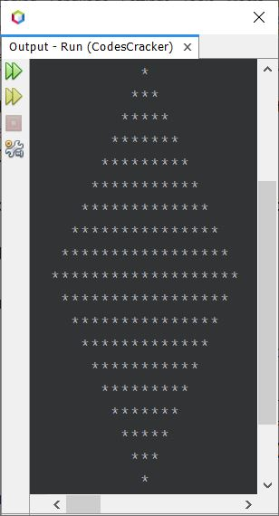

*/

class Main{

static void f1(int n){

for (int i = 0; i < n; i++)

{

for (int j = 0; j < n - i; j++)

{

System.out.print(" ");

}

for (int j = 0; j < 2*i-1; j++)

{

System.out.print("*");

}

System.out.println();

}

for (int i = n - 1; i > 0; i--) {

for (int j = 0; j < n - i ; j++) {

System.out.print(" ");

}

for (int j = 0; j < 2 * i -1; j++) {

System.out.print("*");

}

System.out.println();

}

}

public static void main (String[] args) {

f1(6);

}

}

/* e. hollow diamond

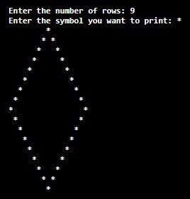

*/

class pattern {

    static void f1(int n) {

        for (int i = 0; i < n; i++) {

            for (int j = 0; j <= n - i; j++) {

                System.out.print(" ");

            }

            for (int j = 0; j <= 2 * i - 1; j++) {

                if (j == 0 || j == 2 * i - 1) {

                    System.out.print("*");

                } else {

                    System.out.print(" ");

                }

            }

            System.out.println();

        }

        for (int i = n - 1; i > 0; i--) {

            for (int j = 0; j <= n - i; j++) {

                System.out.print(" ");

            }

            for (int j = 0; j <= 2 * i - 1; j++) {

                if (j == 0 || j == 2 * i - 1) {

                    System.out.print("*");

                } else {

                    System.out.print(" ");

                }

            }

            System.out.println();

        }

    }

    public static void main(String[] args) {

        f1(6);

    }

}

/* f.

*****

*****

*****

*****

***** */

static void isocelus_traingle_pattern_with_num1(int n) {

        for (int i = 1; i <= n; i++) {

            for (int j = 0; j <= i; j++) {

                System.out.print(" ");

            }

            for (int j = 0; j < n; j++) {

                System.out.print("*");

            }

            System.out.println();

        }

    }

/* g.

A B C D E

F G H I J

K L M N O

P Q R S T

U V W X Y */

public class Main {

public static void main(String[] args) {

char start = 'A';

char end = 'Y';

int size = 5; // Size of the square

for (char ch = start; ch <= end; ch++) {

System.out.print(ch + " ");

if ((ch - start + 1) % size == 0) {

System.out.println();

}

}

}

}

/* h.

1

1 1

1 2 1

1 3 3 1

1 4 6 4 1

1 5 10 10 5 1 */

public class pattern {

    static int fact(int n) {

        int f = 1;

        for (int i = 1; i <= n; i++) {

            f = f * i;

        }

        return f;

    }

    static int n_c_r(int n, int r) {

        int res1 = fact(n);

        int res2 = fact(r) * fact(n - r);

        int res3 = res1 / res2;

        return res3;

    }

    static void print_pascal(int n) {

        for (int i = 0; i <= n; i++) {

            for (int j = 0; j <= n - i; j++) {

                System.out.print(" ");

            }

            for (int j = 0; j <= i; j++) {

                System.out.print(n_c_r(i, j) + " ");

            }

            System.out.println();

        }

    }

    public static void main(String[] args) {

        print_pascal(5);

    }

}

**/* i.**

**\* * * * \***

**\* \***

**\* \***

**\* \***

**\* * * * \***

**\*/**

**/* j.**

**0**

**010**

**01210**

**0123210**

**012343210 */**

public class pattern {

    static void isocelus_traingle_pattern_with_num1(int n) {

        for (int i = 1; i <= n; i++) {

            for (int j = 0; j <= n - i; j++) {

                System.out.print(" ");

            }

            for (int j = 0; j < i; j++) {

                System.out.print(j);

            }

            for (int j = i - 2; j >= 0; j--) {

                System.out.print(j);

            }

            System.out.println();

        }

    }

    public static void main(String[] args) {

        isocelus_traingle_pattern_with_num1(5);

    }

}